



Implementation of Addition of string and integer Using Explicit Conversion
LAB MANUAL

Disclaimer: The content is curated from online/offline resources and used for educational purpose only
Implementation of Addition of string and integer Using Explicit Conversion
Objective:
To demonstrate how to add a string and an integer in Python using explicit type conversion.
Problem Statement:
In Python, you cannot directly add a string and an integer because they are different data types. This lab manual demonstrates how to use explicit type conversion to achieve this task by converting one of the data types to match the other.
Equipment Required:
- Install VS Code - https://code.visualstudio.com/download
- Download Python Installer File - https://www.python.org/downloads/
Prerequisites:
- Basic Computer Skills - Anyone starting to learn computer programming needs basic computer skills. Python is a cross-platform language, so it makes no difference whether you use a macOS, Windows, or even Linux.
Procedure:
Task 1: Implicit Conversion with String Concatenation
Code: Type conversion of string

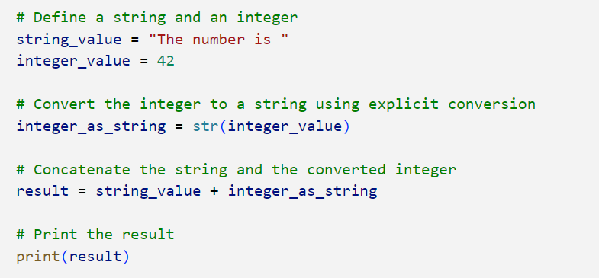

Output:
